SUBARU XV and Impreza Win Top ASV+++ Rating

in 2018-2019 JNCAP Preventive Safety Performance Assessment

- Subaru XV and Impreza win the JNCAP Top ASV+++ Rating 2018-2019
- Both models achieved maximum top rating*¹

Zaventem, May 30, 2019 – Subaru Europe, the European subsidiary of Subaru Corporation, announced today that the Subaru XV and Impreza models (Japanese market specifications) received the top rating of Advanced Safety Vehicle Triple Plus (ASV +++^{*1}) in the 2018-2019 Japan New Car Assessment Program (JNCAP) preventive safety performance assessment conducted by the Ministry of Land, Infrastructure, Transport (MLIT) and the National Agency for Automotive Safety and Victims’ Aid (NASVA).

In April 2017, these two models have won the Grand Prix Award in the 2016-2017 JNCAP collision safety performance assessment for earning the highest ever score at the time*2 as well as the Special Award for having a pedestrian protection airbag as standard. Together with the Grand Prix Award in the latest 2018-2019 collision safety performance assessment won by the all-new Forester, these achievements show Subaru’s commitment to its All-Around Safety philosophy.

Both Subaru XV and Impreza feature Subaru’s unique “EyeSight” Driver Assist system as standard equipment. EyeSight uses a pair of cameras for forward recognition and provides assist functions including pre-collision braking, pre-collision throttle management and lane keep assistance to support the driver. In addition, optional High Beam Assist^{*3} function automatically switches the headlights between the high and low beams by detecting the lights in front of the vehicle with EyeSight cameras and supports the night time driving.

Subaru will continue to enhance its primary, active, passive, and pre-collision safety technologies under its “All-Around Safety” philosophy, which underpins enjoyment and peace of mind for all drivers and passengers, and target to achieve zero fatal road accidents^{*4} by 2030.
1: With 118.8 points out of 126 points
*2:199.7 points out of 208 points (in the scoring method used until the assessment in 2017-2018)
*3: Available in an optional EyeSight Safety Plus package
*4: Traffic accident deaths of Subaru drivers/passengers and people including pedestrians/cyclists Subaru cars collide with

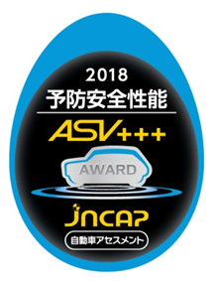  JNCAP ASV+++ | 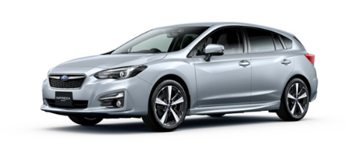 | Impreza SPORT 2.0i-S EyeSight
 | 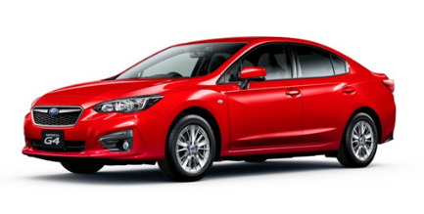 | Impreza G4 1.6i-L EyeSight
 | 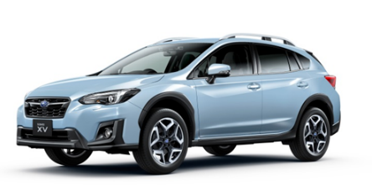 | SUBARU XV 2.0i-S EyeSight
###

